**React 11**

**Aim:** Create a React Application “eventexamplesapp” to handle various events of the form elements in HTML.

Create “Increment” button to increase the value of the counter and “Decrement” button to decrease the value of the counter. The “Increase” button should invoke multiple methods.

* 1. To increment the value
  2. Say Hello followed by a static message.

**Counter.js:**

import React, { useState } from "react";

function Counter() {

  const [count, setCount] = useState(0);

  function increment() {

    setCount(prev => prev + 1);

    sayHello();

  }

  function sayHello() {

    console.log("Hello from React - counter updated!");

  }

  function decrement() {

    setCount(prev => prev - 1);

  }

  return (

    <div className="card">

      <h2>Counter: {count}</h2>

      <button onClick={increment}>➕ Increment</button>

      <button onClick={decrement}>➖ Decrement</button>

    </div>

  );

}

export default Counter;

**CurrencyConverter.js:**

import React, { useState } from "react";

function CurrencyConvertor() {

  const [rupees, setRupees] = useState("");

  const [euros, setEuros] = useState("");

  const convert = (e) => {

    e.preventDefault();

    const rate = 0.011; // Example: 1 INR = 0.011 EUR

    const converted = parseFloat(rupees) * rate;

    setEuros(converted.toFixed(2));

  };

  return (

    <div className="card">

      <h2>INR to Euro Convertor</h2>

      <form onSubmit={convert}>

        <input

          type="number"

          placeholder="Enter INR"

          value={rupees}

          onChange={(e) => setRupees(e.target.value)}

        />

        <button type="submit">Convert</button>

      </form>

      {euros && <p>💶 Euros: €{euros}</p>}

    </div>

  );

}

export default CurrencyConvertor;

**SyntheticEvent.js:**

import React from "react";

function SyntheticEvent() {

  function handleClick(e) {

    e.preventDefault();

    alert("I was clicked using Synthetic Event!");

  }

  return (

    <div className="card">

      <h2>Synthetic Event</h2>

      <button onClick={handleClick}>Click Me</button>

    </div>

  );

}

export default SyntheticEvent;

**WelcomeButton.js:**

import React from "react";

function WelcomeButton() {

  function greet(message) {

    alert(message);

  }

  return (

    <div className="card">

      <h2>Welcome Message</h2>

      <button onClick={() => greet("Welcome to the Event Lab!")}>Say Welcome</button>

    </div>

  );

}

export default WelcomeButton;

**App.css:**

/* Global Styles */

body {

  font-family: 'Segoe UI', 'Roboto', sans-serif;

  background: linear-gradient(135deg, #dfe9f3 0%, #ffffff 100%);

  margin: 0;

  padding: 0;

  color: #222;

}

/* Main Container */

.app {

  padding: 2rem;

  text-align: center;

}

/* Card Design */

.card {

  background: #ffffff;

  margin: 20px auto;

  padding: 20px;

  border-radius: 16px;

  max-width: 500px;

  box-shadow: 0 10px 20px rgba(0, 0, 0, 0.1);

  transition: transform 0.2s ease;

}

.card:hover {

  transform: scale(1.01);

}

/* Button Styles */

button {

  padding: 12px 24px;

  margin: 10px 5px;

  font-size: 1rem;

  font-weight: 600;

  border: none;

  border-radius: 8px;

  cursor: pointer;

  background-color: #0078D7;

  color: #fff;

  box-shadow: 0 4px 6px rgba(0, 0, 0, 0.1);

  transition: background-color 0.3s ease, transform 0.2s ease;

}

button:hover {

  background-color: #005EA6;

  transform: translateY(-2px);

}

/* Input Styles */

input {

  padding: 10px;

  width: 60%;

  max-width: 300px;

  margin: 10px 0;

  font-size: 1rem;

  border: 2px solid #ccc;

  border-radius: 6px;

  transition: border-color 0.3s ease;

}

input:focus {

  border-color: #0078D7;

  outline: none;

}

/* Heading Styling */

h1 {

  color: #1a1a1a;

  margin-bottom: 30px;

}

h2 {

  color: #333;

  margin-bottom: 15px;

}

/* Paragraph */

p {

  font-size: 1.1rem;

  color: #444;

  margin-top: 10px;

}

**App.js:**

import React from "react";

import Counter from "./components/Counter";

import WelcomeButton from "./components/WelcomeButton";

import SyntheticEvent from "./components/SyntheticEvent";

import CurrencyConvertor from "./components/CurrencyConvertor";

import "./App.css";

function App() {

  return (

    <div className="app">

      <h1>🎯 React Events Playground</h1>

      <Counter />

      <WelcomeButton />

      <SyntheticEvent />

      <CurrencyConvertor />

    </div>

  );

}

export default App;

**Output 01:**

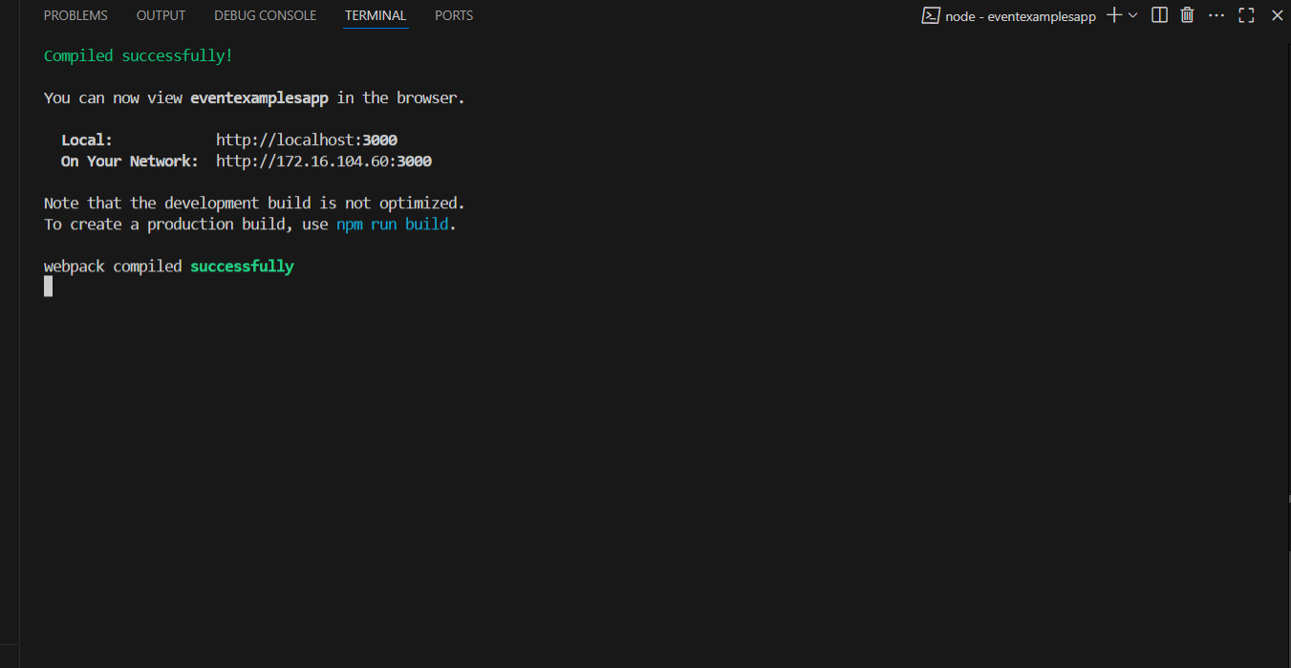

**Output 02:**

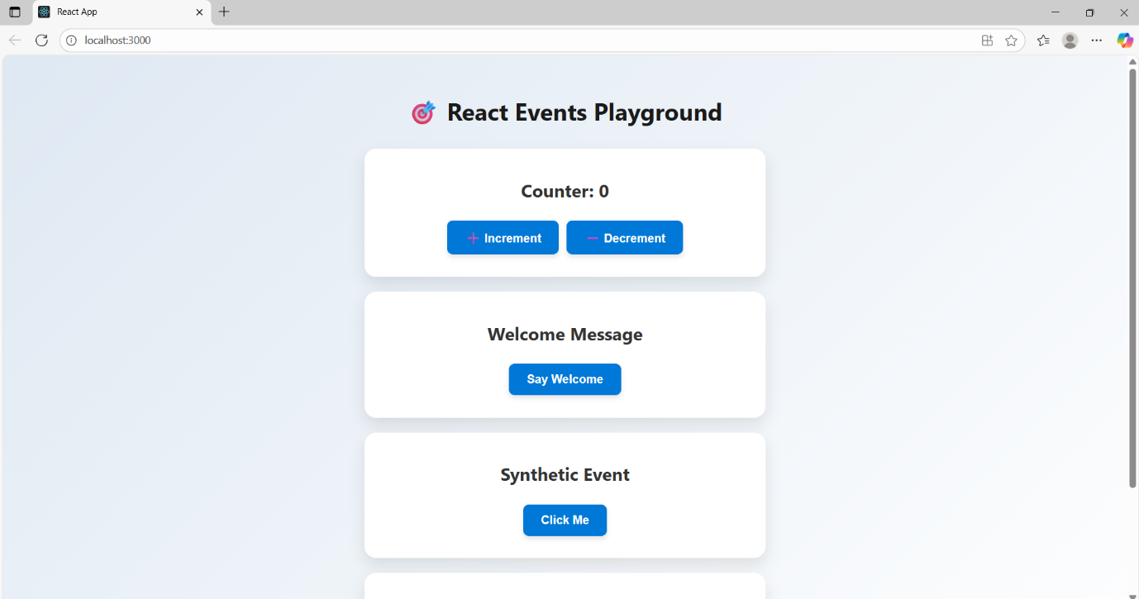

**Output 03:**

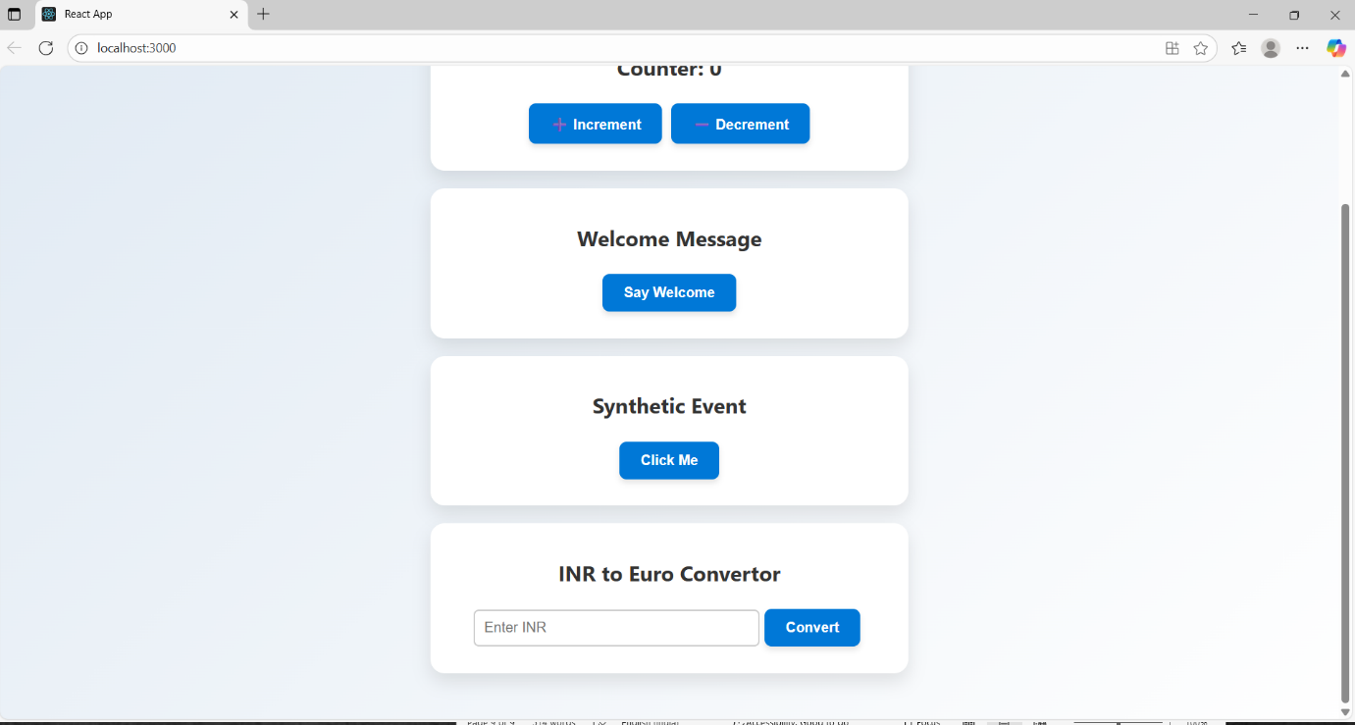**Output 04: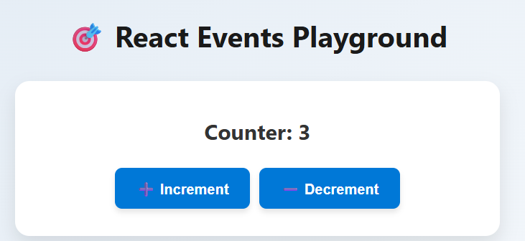Output 05:**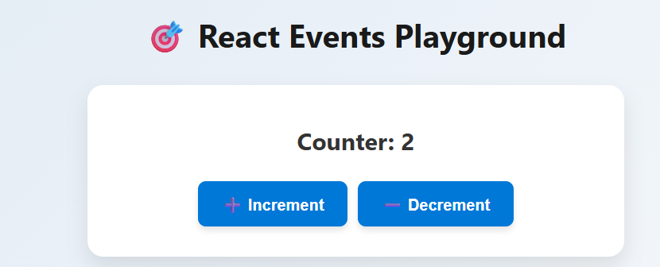

**Output 06: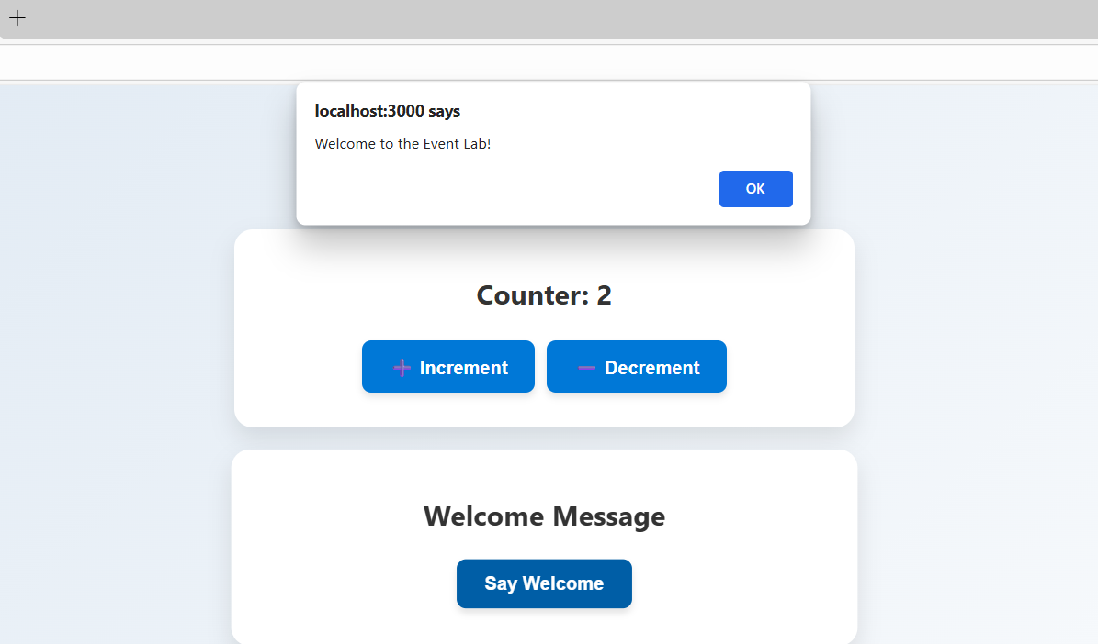Output 07: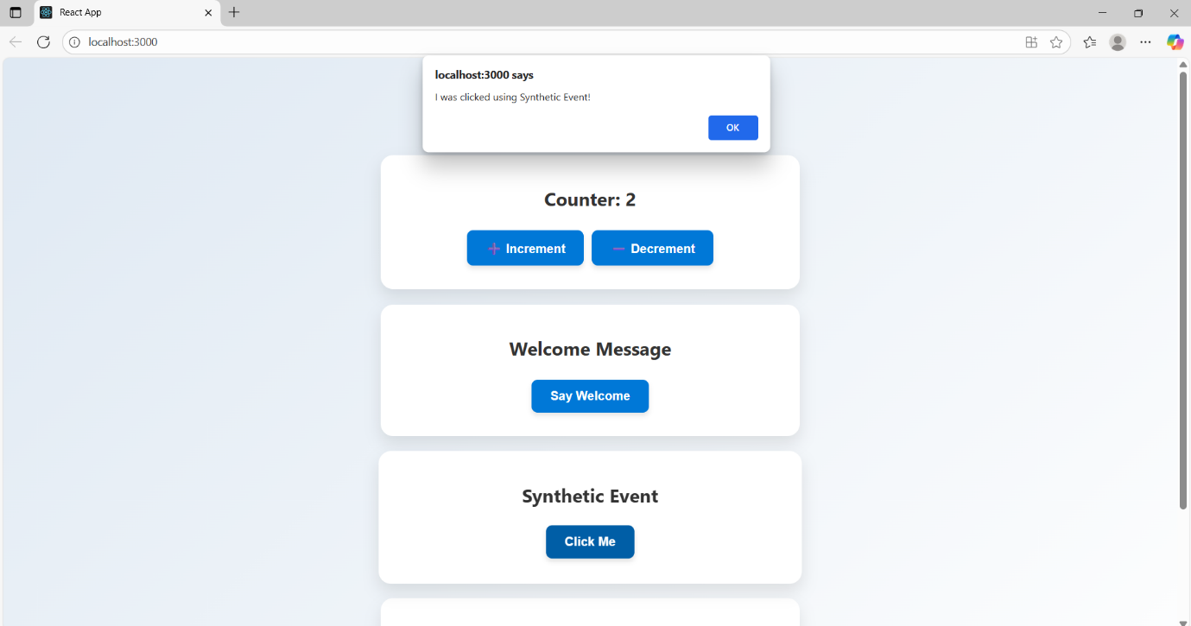Output 08:**